To deploy Frontend to Firebase, first log in to Firebase: <https://firebase.google.com>

Next, click Go to console

Click Create a project and name the Project

Click Continue

Here is the project after creation

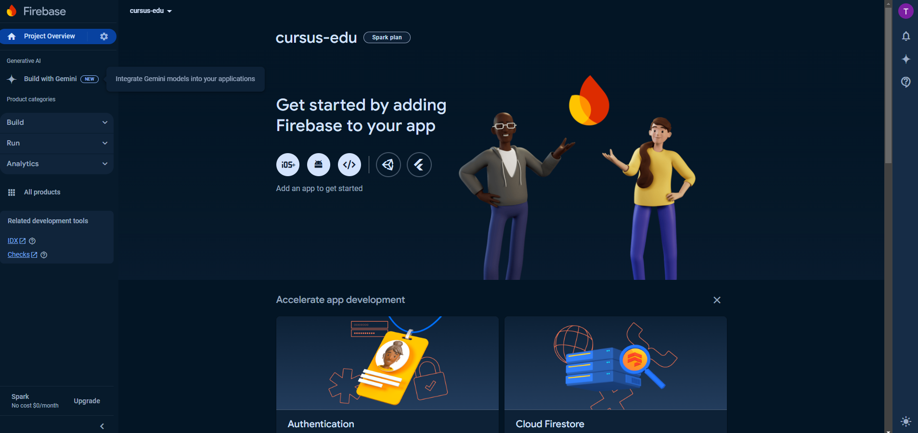

Select Build and select Hosting

Select Get started

Open the frontend project in visual studio code, open terminal and run the following command:

npm install -g firebase-tools

Next run the command: firebase login and log in with your Firebase account

Next run the command: firebase init

Type Y and Enter

Move down to Hosting: Configure files for Firebase Hosting and (optionally) set up GitHub Action deploys with the down arrow key, select with the Space key and Enter

Type dist and Enter

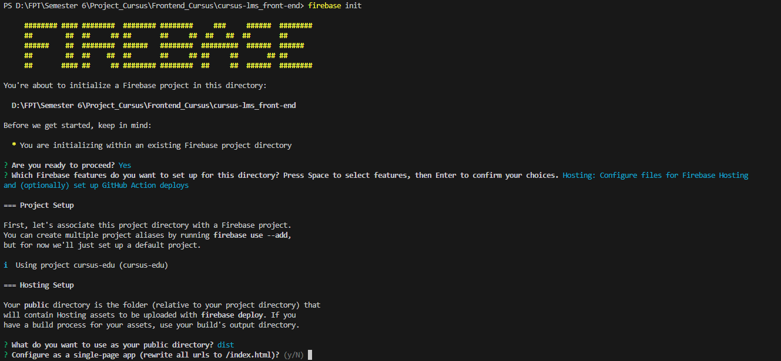

Select Y and Enter

Select n and Enter

Select Y and Enter

Run command: npm run build

Next run the command: firebase deploy

Frontend project has been hosted using firebase, open the Hosting URL in the browser

Hosting with Firebase successfully

End!